Name: Somnath R. Shintre Roll No:

Class: TE CSE Batch:

**Title: -**  Take file name as input to your program through command line, if file exists the open and display contents of the file. After displaying contents of file ask user – 1.do you want to add the data at the end of file or 2. replace specified text in file by other text. Based on user’s response, then accept data from user and append it to file. If file in not existing then create a fresh new-file and store user data into it. Also. User should type exit on new line to stop the program. Do this program using Character stream classes.

**Program: -**

import java.io.*;

import java.util.Scanner;

class FileHandling

{

public static int appendStrToFile(String fileName, String str)

{

try {

// Open given file in append mode.

BufferedWriter out = new BufferedWriter(new FileWriter(fileName, true));

out.write(str);

out.close();

return 1;

} catch (IOException e) {

return 0;

}

}

public static void main(String args[])

{

String file_name;

Scanner sc = new Scanner(System.in);

System.out.print("\n\t--File Handling--\n");

System.out.print("Enter the file name: ");

file_name = sc.next();

try {

FileReader fr = new FileReader(file_name);

int data, req = 1;

System.out.println("File Exits..");

while((data=fr.read())!=-1) {

System.out.print((char)data);

}

System.out.println("\n1.do you want to add the data at the end of file or \n2.replace specified text in file by other text");

System.out.print("Choice one: ");

req = sc.nextInt();

String adata;

if(req == 1) {

System.out.print("\nEnter the data: ");

sc.useDelimiter("\\t");

while(true){

adata = sc.next();

break;

}

//adata = "\n" + adata;

int c = appendStrToFile(file_name, adata);

if(c == 1)

System.out.println("Data appended..");

else

System.out.println("Data not appended..");

}

if(req == 2) {

//Instantiating the Scanner class to read the file

Scanner sc1 = new Scanner(new File(file_name));

//instantiating the StringBuffer class

StringBuffer buffer = new StringBuffer();

//Reading lines of the file and appending them to StringBuffer

while (sc1.hasNextLine()) {

buffer.append(sc1.nextLine()+System.lineSeparator());

}

String fileContents = buffer.toString();

//closing the Scanner object

sc1.close();

String oldLine;

System.out.print("\nEnter the oldline: ");

sc.useDelimiter("\\t");

while(true){

oldLine = sc.next();

break;

}

String newLine;

System.out.print("\nEnter the newLine: ");

while(true){

newLine = sc.next();

break;

}

//Replacing the old line with new line

fileContents = fileContents.replaceAll(oldLine, newLine);

//instantiating the FileWriter class

FileWriter writer = new FileWriter(file_name);

System.out.println("");

System.out.println("New data: "+fileContents);

writer.append(fileContents);

writer.flush();

}

} catch(FileNotFoundException fne) {

System.out.println("File Does Not Exits..");

try{

File newf = new File(file_name);

newf.createNewFile();

System.out.println("New file cerated..");

FileWriter myWriter = new FileWriter(file_name);

System.out.print("Write data into file: ");

String fdata;

sc.useDelimiter("\\t");

while(true){

fdata = sc.next();

break;

}

myWriter.write(fdata);

myWriter.close();

System.out.println("Successfully wrote to the file.");

} catch (IOException e) {

System.out.println("Exception Occurred" + e);

}

} catch (IOException ie) {

System.out.println("Exception Occurred" + ie);

}

}

}

**Output: - 1) Appending Data to file**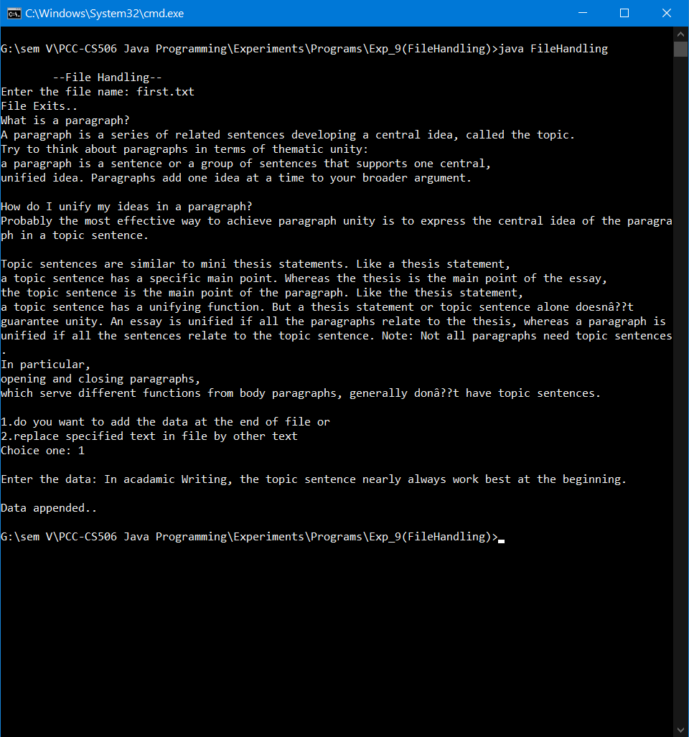

**2) Replacing specific text**

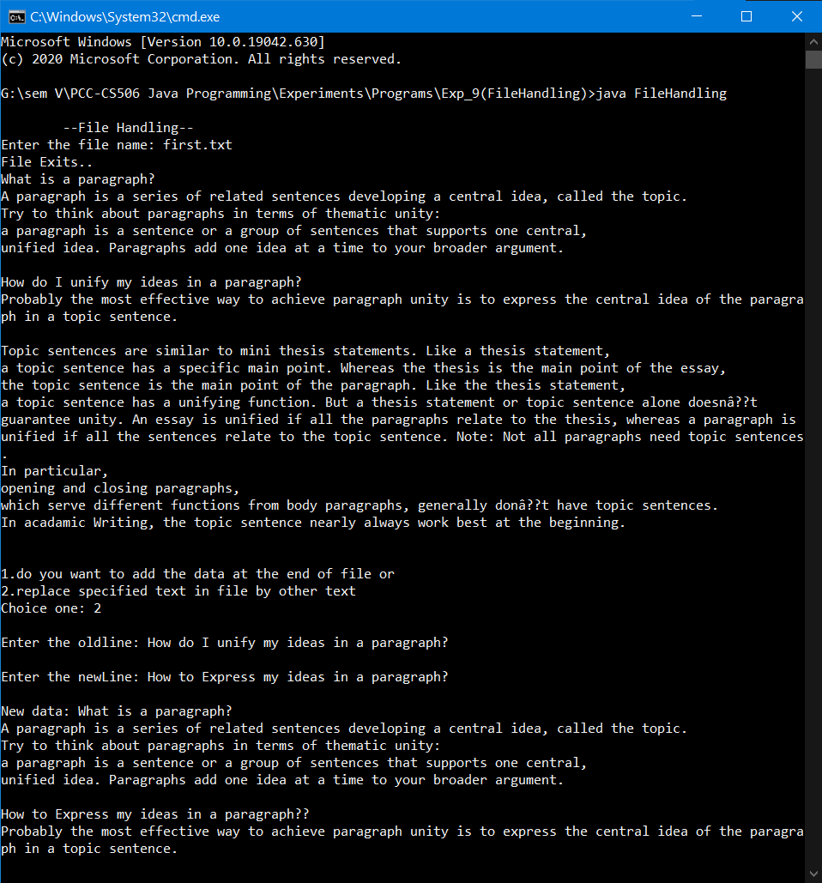

**3) Creating new file and storing the content**

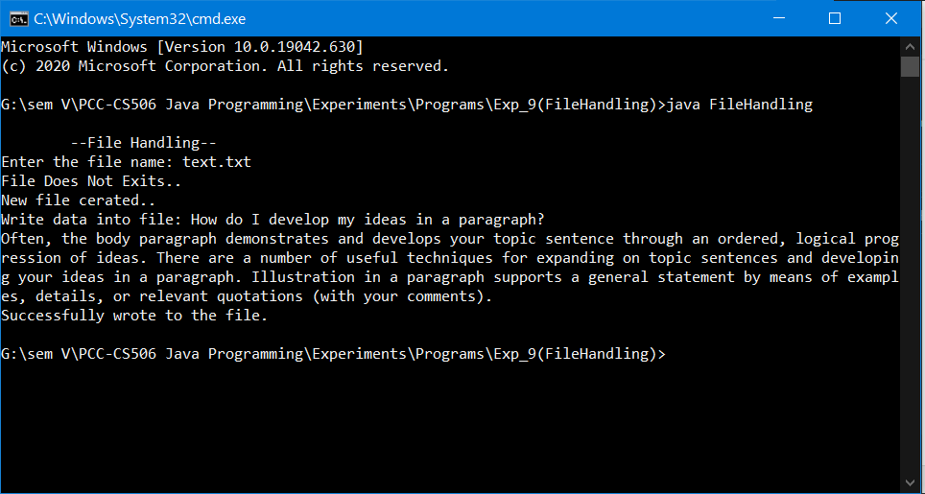

**The new file and the data written**

